Product Backlog

# User:

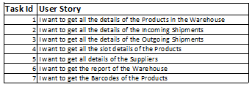

# User Story Estimation: ((Cust Value + Busi Value)*Urgency)/Job Size

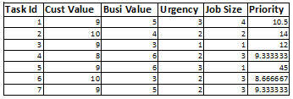

# Product Backlog:

